School Voting System (voting-app3)

Student User Manual

Version 1.0 — November 3, 2026
Prepared from the codebase and the interactive guide (guide/)

Table of Contents
Right-click here and choose “Update Field” to build the table of contents.

1. Welcome
Welcome to the School Voting System. This is where you register as a voter, review the candidates running in your Student Supreme Government (SSG) and Department Student Government (DSG) elections, and cast your ballot — securely and privately. Your votes are stored anonymously: no one, not even administrators, can see which candidate you chose.
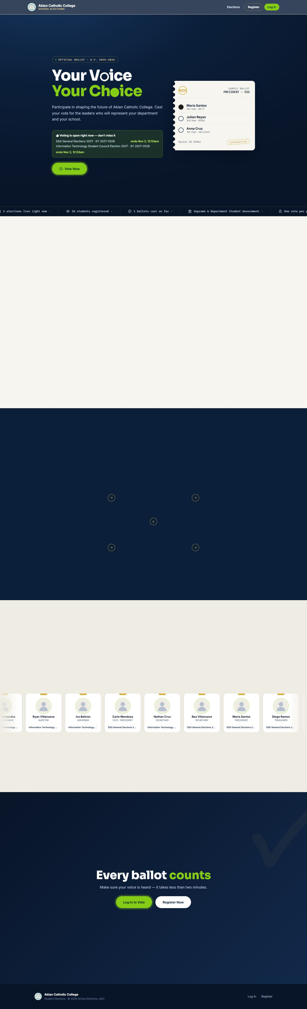
Landing page

2. Quick start (six steps)
1. Register an account with your 9-digit student ID.
2. Log in with your ID and password.
3. Choose an election from your dashboard.
4. Review candidates and their platforms.
5. Submit your ballot and confirm.
6. View results live once you have voted (subject to visibility rules).

3. Registering an account
Open the landing page and click Register, or go straight to the registration page.
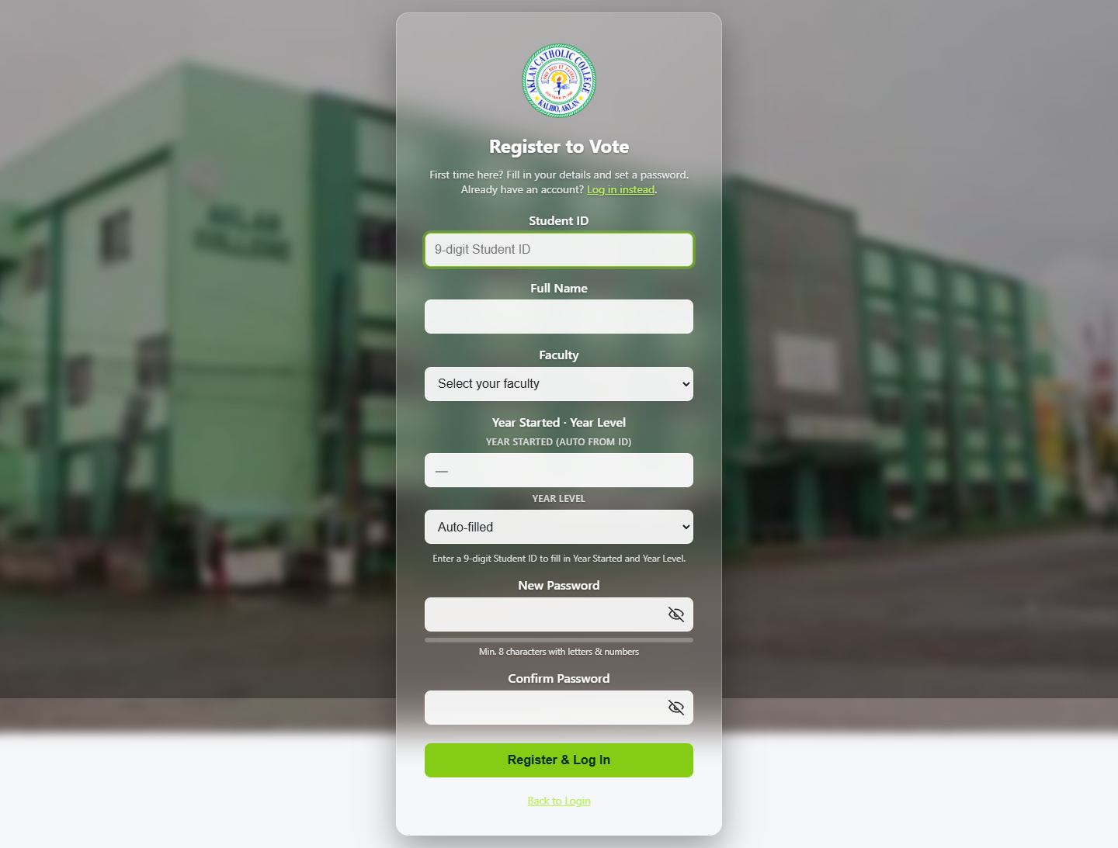
Registration page
Field | Rule
--- | ---
Student ID | Exactly 9 digits. The first 4 digits are your starting school year — for a first-year student in school year 2026–2027 this is 2026xxxxx. You cannot type this by hand; the system reads it from your ID.
Full name | Your enrolled name as it appears on records.
Department / course / other details | As prompted; these determine which DSG positions you may vote in.
Password | At least 8 characters with at least one letter and one number.

After registering, your year level is derived automatically: (current school year start − your ID's start year) + 1. Example: ID 202310105 during SY 2026–2027 → year level 4.
Common registration errors
Message | Meaning | What to do
--- | --- | ---
Invalid student ID format | Not exactly 9 digits | Re-enter your full ID number
Student ID already registered | An account exists for this ID | Use Log In, or see troubleshooting §10
Password does not meet the policy | Fewer than 8 chars, or missing a letter/number | Pick a stronger password
Too many attempts | Registration blocked after 5 tries in 10 minutes | Wait 10 minutes and try again

4. Logging in
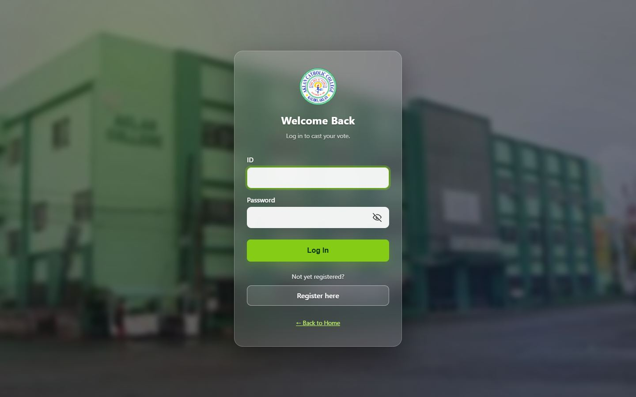
Login page
1. Enter your student ID and password.
2. Click Log In. Use the eye icon to show/hide your password while typing.
If you log in successfully you land on your dashboard. Two special cases:
- "Please update your account" — if you have been enrolled longer than the four-year window without a year-level declaration, the system asks you to confirm your current status once before continuing (see §9).
- Wrong ID or password — the message is deliberately the same whether the ID or the password is wrong. This protects you: nobody can probe the system to find out whether your ID exists.
Too many failed logins (8 in 5 minutes) temporarily block further attempts from your network.

5. Your dashboard
After logging in you see the dashboard with four panels: Home, Vote Now, Candidates, and Results. Switch panels using the sidebar (on mobile, the hamburger menu).
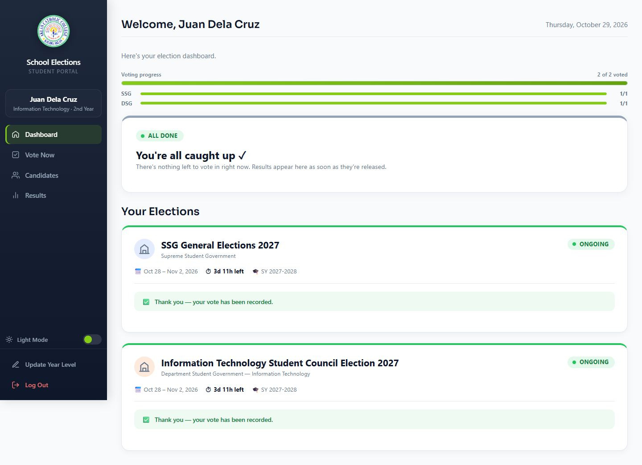
Student dashboard
Home panel shows:
- A greeting with your name and your school year.
- Voting progress — how many elections you have participated in. Submitting a ballot counts, even if you skipped every position.
- One card per election you may vote in, with live status and countdown: Ongoing (voting open now), Upcoming, Paused, or Ended.
- A Vote Now button for open elections you have not voted in yet.
Light/dark mode — use the theme toggle; your preference is remembered in your browser.

6. Voting

6.1 Opening the ballot
From the Home panel, click Vote Now on an election card. If more than one election is open and unvoted, the dashboard offers a combined ballot: a single page covering all of them, with each election clearly sectioned and its own progress bar. You can also vote in each election separately — both paths produce the same result.
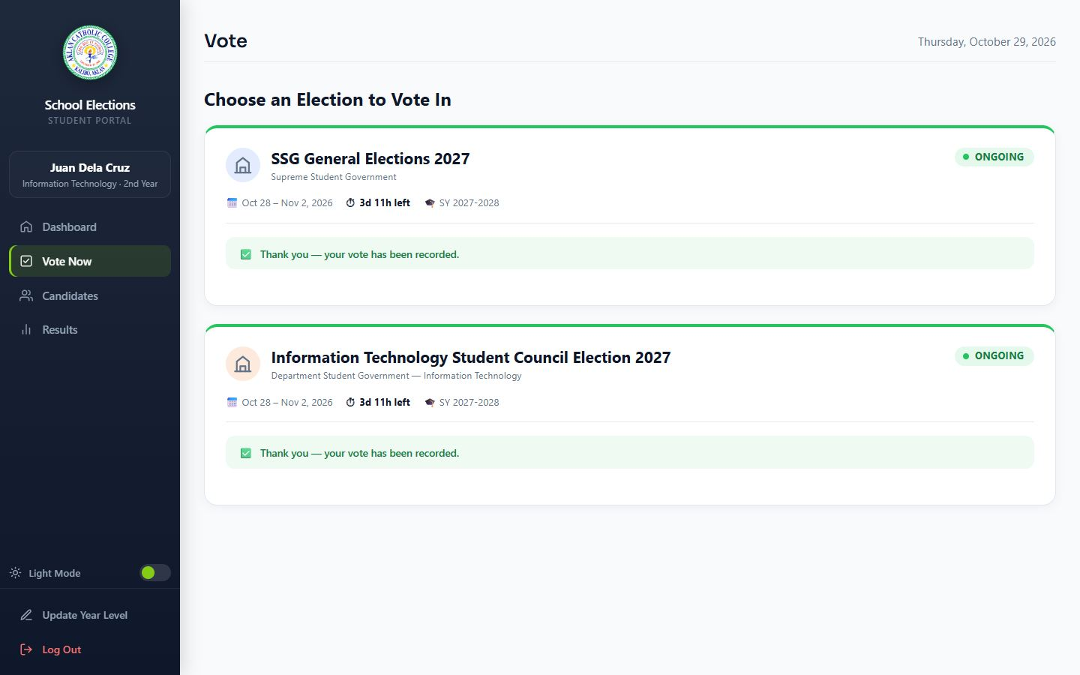
Ballot page

6.2 Filling it in
- Each position (President, Vice President, …) lists its candidates with photo, name, and party.
- Single-choice positions use round radio buttons — pick one.
- Some positions allow multiple selections (shown by the instruction, e.g. "Select up to 3"). Square checkboxes let you pick up to the stated number; other options grey out when you reach the cap. Clicking a selected radio again clears your choice (abstain from that position).
- You may skip any position — skipping is a valid choice and is recorded as participating, not as a vote for anyone.
- Year-level-restricted positions (e.g. "4th Year Representative") only appear if they apply to you.
- If you leave and return before submitting, your draft selections are saved so you can continue later.

6.3 Submitting
1. Click Submit Ballot. A confirmation modal lists what you are about to do.
2. Click Cast My Vote to confirm, or Go Back to keep editing.
3. On success you see a confirmation modal. This is final — a submitted ballot cannot be changed or re-cast.
The counter at the top shows "N of M positions answered" — it is only a guide; you may submit with unanswered positions.

7. Viewing results
Open the Results panel to see counts for each election.
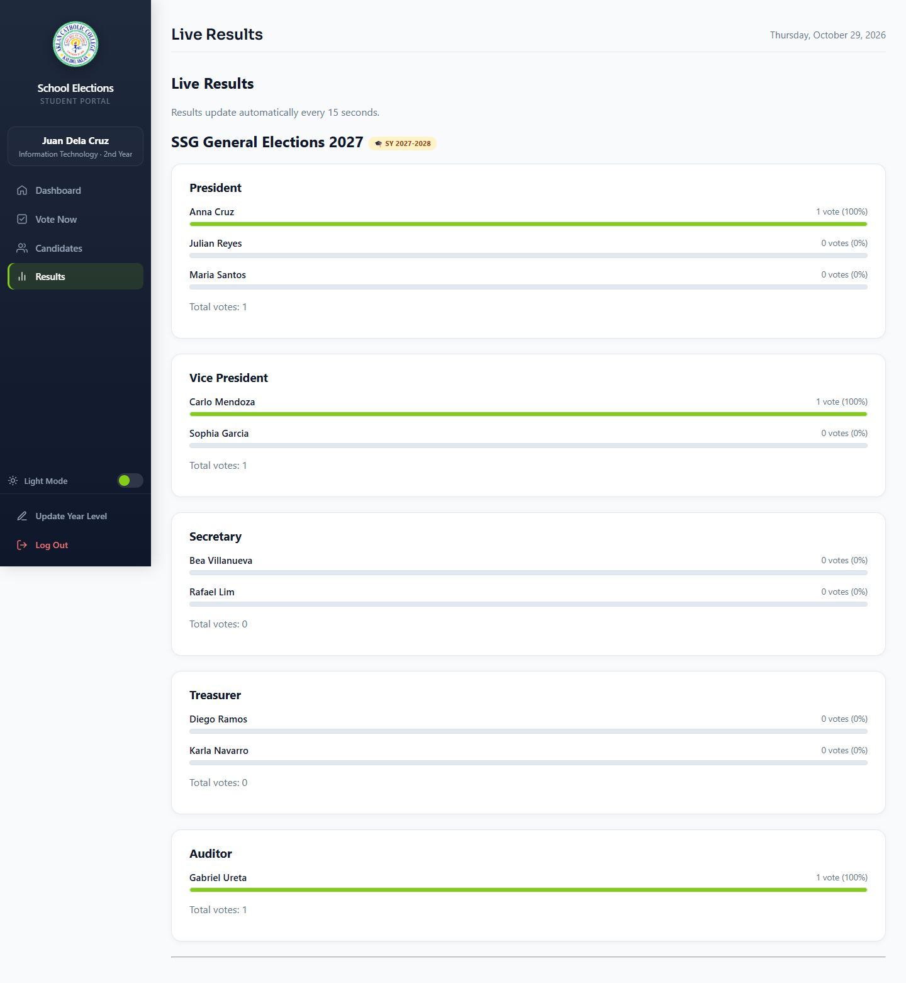
Results panel
- Every candidate's vote count, percentage, and a bar, per position.
- A Leading badge marks the candidate(s) currently ahead. If two candidates are exactly tied for the lead, both show Leading — ties are never auto-broken by the system.
- Results refresh automatically every 15 seconds while the page is open.
- Whether results are visible during voting is a decision made per election by the administrator (always / only after the election ends / never). If an election's results are hidden, you simply see a notice.
Results are also available without logging in on the public results page, subject to the same visibility rules.

8. Browsing candidates
The Candidates panel is a directory of everyone running, grouped by election and position, with SSG and DSG tabs, and a search box that filters by name, party, or course as you type.
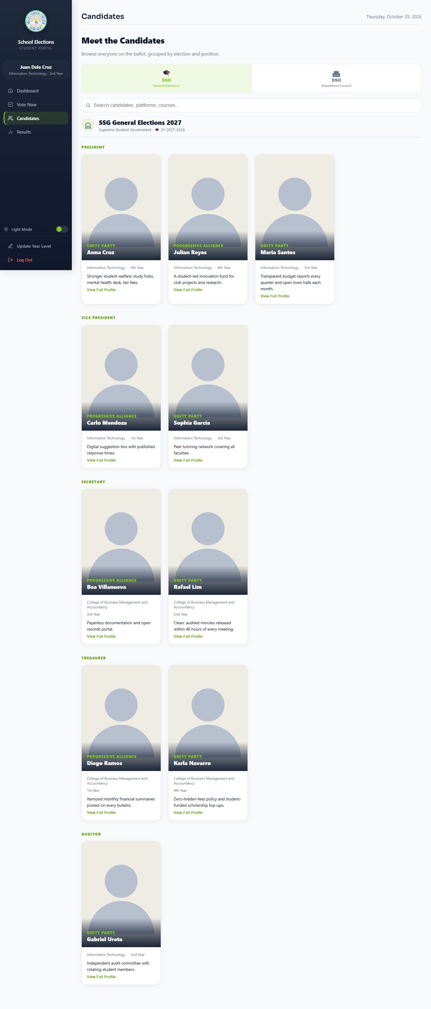
Candidates directory
Click View Full Profile on any card for the candidate's complete platform statement. You only ever see candidates from elections and positions you are eligible to vote in.

9. Updating your enrollment details
If you are prompted to update your account (the needs_account_update flow), the system needs you to declare your current year level — for example after taking a leave, repeating a year, or returning after a gap.
- Choose the declaration that matches your situation and save.
- This can be done once per school year; afterwards the page locks until the next school year starts.
- Your declaration adjusts what you see and can vote in (year-restricted positions) for the rest of the year.
You can also change your password from your account page. If an administrator reset your password for you, you received a temporary one — log in with it and set a new password right away.

10. Troubleshooting
Problem | Likely cause | Fix
--- | --- | ---
"Invalid ID or Password" | Typo, or wrong password | Check the ID is 9 digits; use the show-password icon; if forgotten, ask an admin to reset it
No elections on my dashboard | No election is currently open to you (ended, archived, draft, or for another department/year) | Check the public results page; contact the admin office
Vote Now button missing on an open election | You already submitted a ballot in it | Check the Results panel — participation is recorded
"Too many attempts" | Rate limiting after repeated failures | Wait the stated window (5–10 minutes) and retry
Page says results are not visible | Admin set visibility to after-end or never | Check back after the election closes
Confirm modal did not appear | The submit button was double-clicked before the page finished loading | Reload and submit again
Photos not loading | Slow network | Reload; candidate data itself loads independently of photos

11. Frequently asked questions
Are my votes secret?
Yes. Ballot content is stored anonymously. Administrators can see that you submitted a ballot (participation) but never what you submitted.
Can I vote twice?
No. Submitting a ballot locks your participation in that election for the whole event.
Can I change my vote after submitting?
No — a submitted ballot is final. That is why the confirmation modal asks you to double-check first.
I'm a repeating student. Which positions do I see?
Your year level is derived from your student ID (and any declaration you made in the update-account flow). Year-restricted positions follow that.
Do I have to vote for every position?
No. Skipping is allowed and still counts as participation.
What does "Leading" mean when two people have it?
They are exactly tied for first. The system reports ties honestly rather than picking a winner for you.
Does it work on my phone?
Yes — the layout adapts to mobile screens; the sidebar becomes a hamburger menu.

12. Getting help
For account problems (forgotten password, wrong year level, name corrections) contact your student affairs office or the election administrator. Include your full student ID and describe what you see on screen.

